ACTIVITY 3: Bookshelf API + UI

Members:
Mira, Jhan Miguel M.
Imperial, Lance Ivan V.
Kadusale, Leimarc
Valentin, John Harvey
Garbanzos, Edcel

The app allows users to create authors and categories as part of its main features. Once both authors and categories are created, users can then add books. The app provides options to edit and delete any of the created items for easy management.

Key Features:
- Library Management: Complete CRUD operations (Create, Read, Update, Delete) for Books, Authors, and Categories.
- Relational Data: Link books with authors and categories for organized library structure.
- Inline Editing: Edit entries directly with pre-filled forms and cancel functionality.
- Confirmation Modals: Safe deletion with custom confirmation dialogs preventing accidental data loss.
- Empty States: Helpful messages when no data exists in any section.
- Real-time Updates: Immediate UI refresh after any CRUD operation.
Screenshots of Working System

# User Interface Screenshots
- Main Dashboard – Empty State
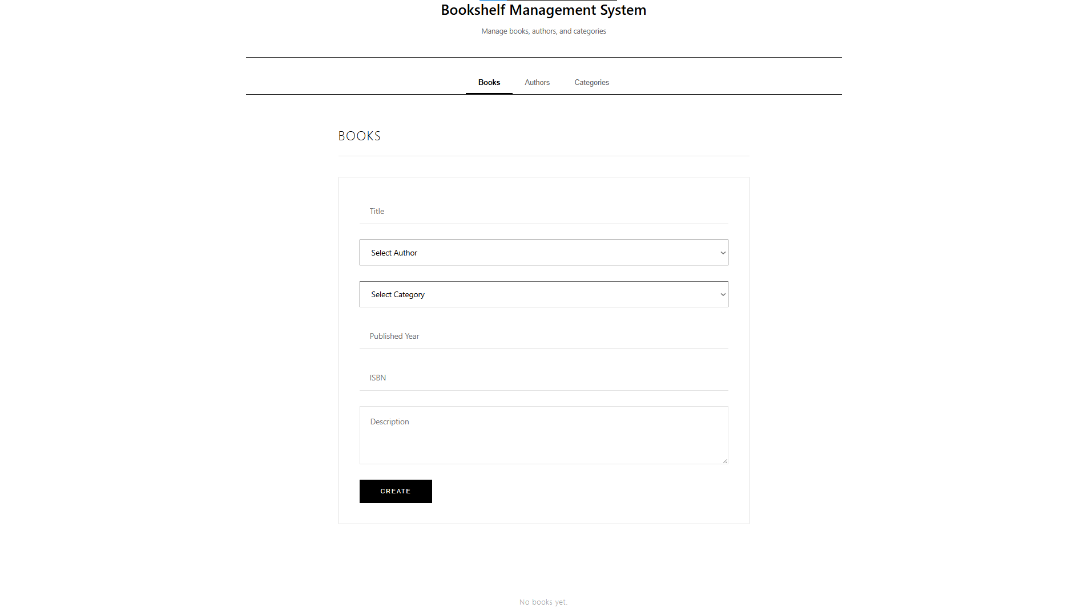

- Clean interface showing all books with their details including author, category, year, ISBN, and description.

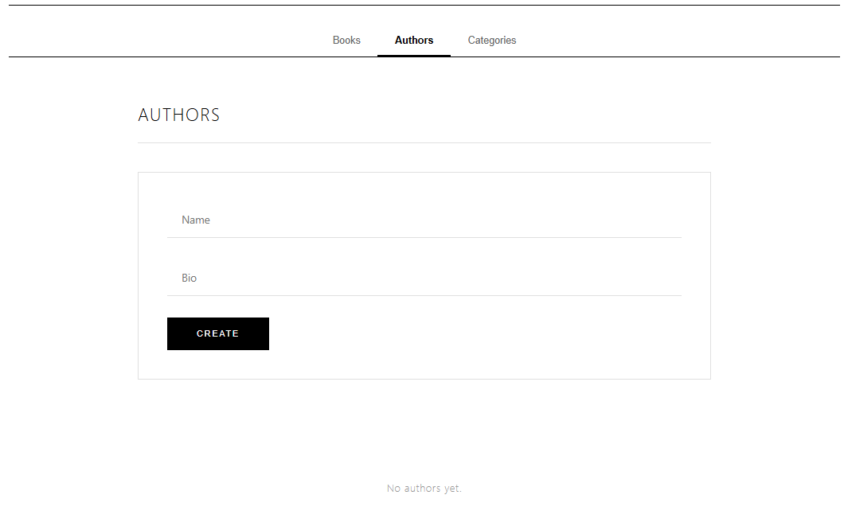
- Authors Management Section

- List of all authors with their biographical information, edit and delete options.
3. Categories Management Section
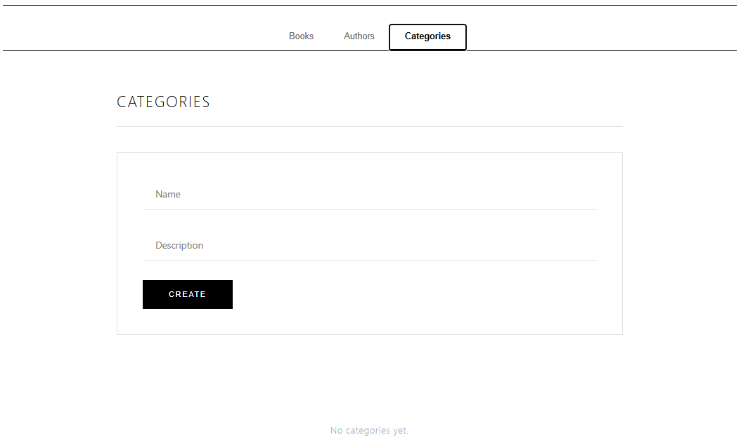

- Categories list showing category names and descriptions with management options.

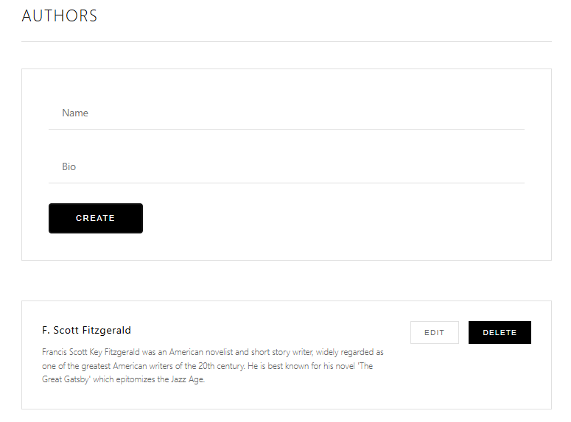
4. Create New Author

- Form for adding new authors

5. Create New Category
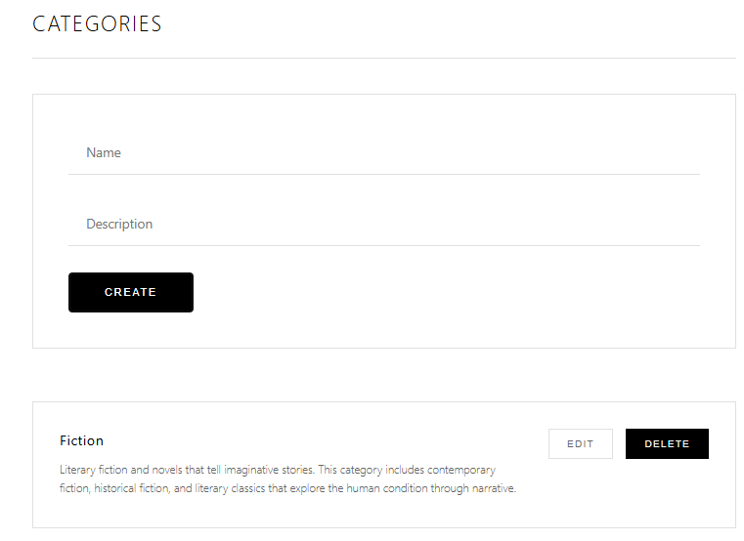

- Form for adding new categories

6. Create New Book
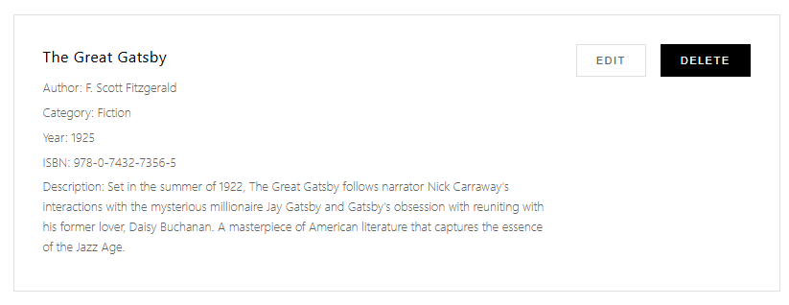
- Output for adding new books

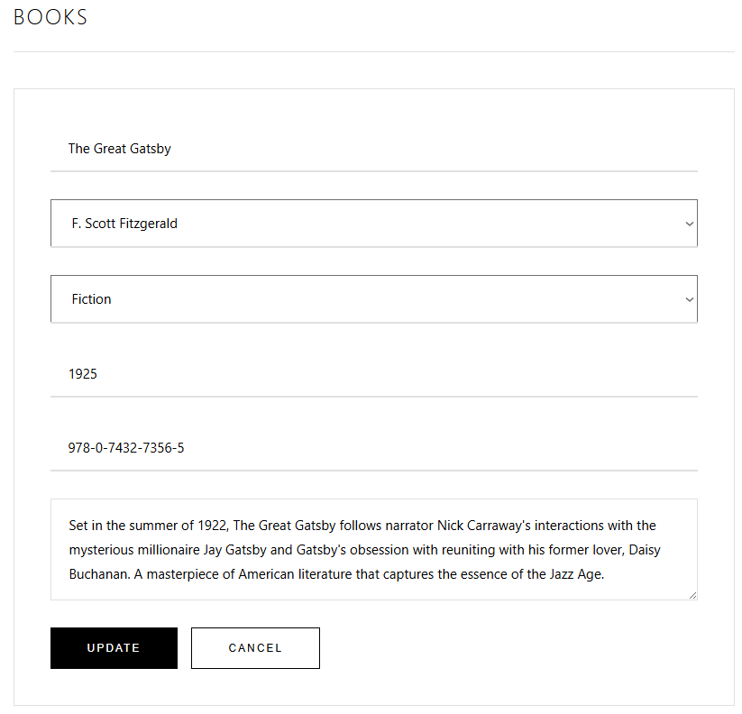
7. Edit Book Form

- Edit existing book with pre-filled data.

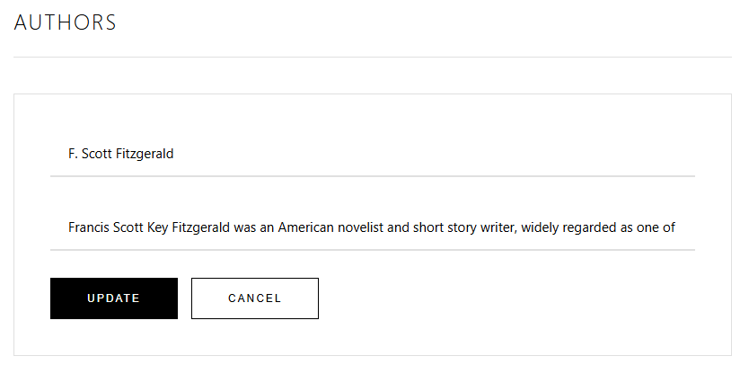
8. Edit Author Form

- Edit existing author with pre-filled data.
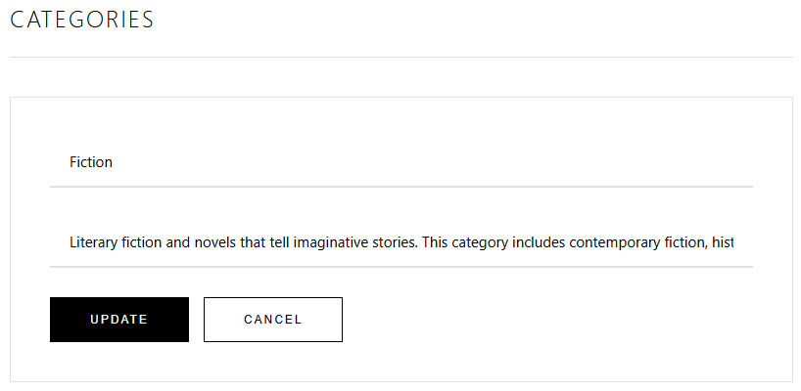
10. Edit Category Form

- Edit existing category with pre-filled data.

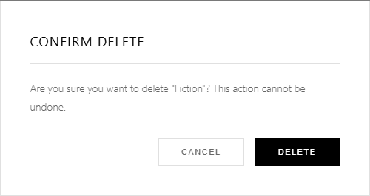
11. Delete Confirmation Modal

- Prevents accidental deletion.

API Examples (Postman)

12.POST /books - Create New Book

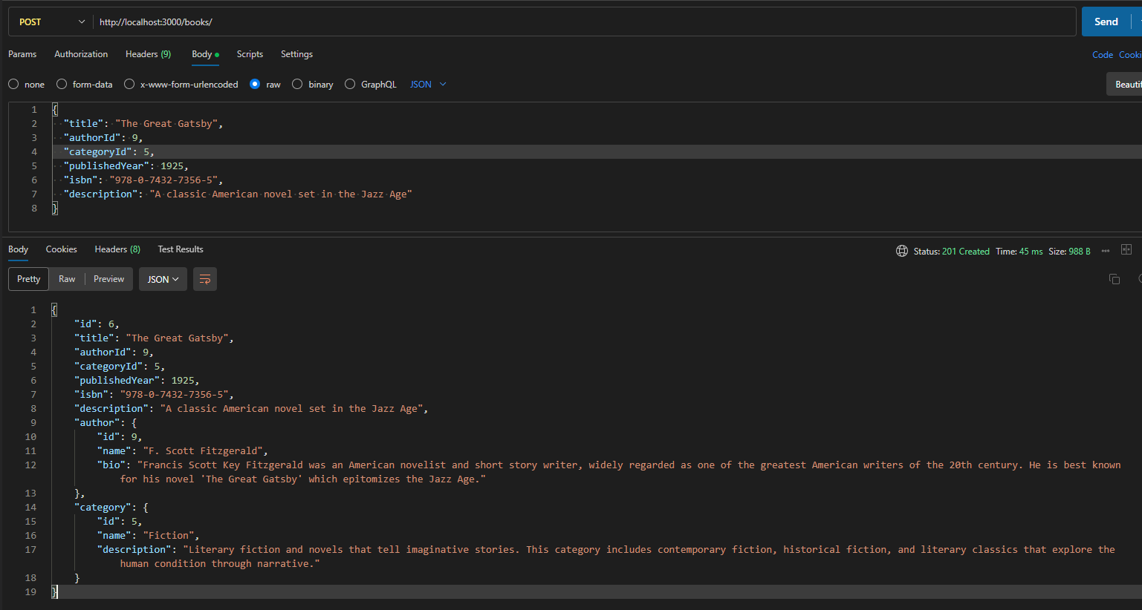

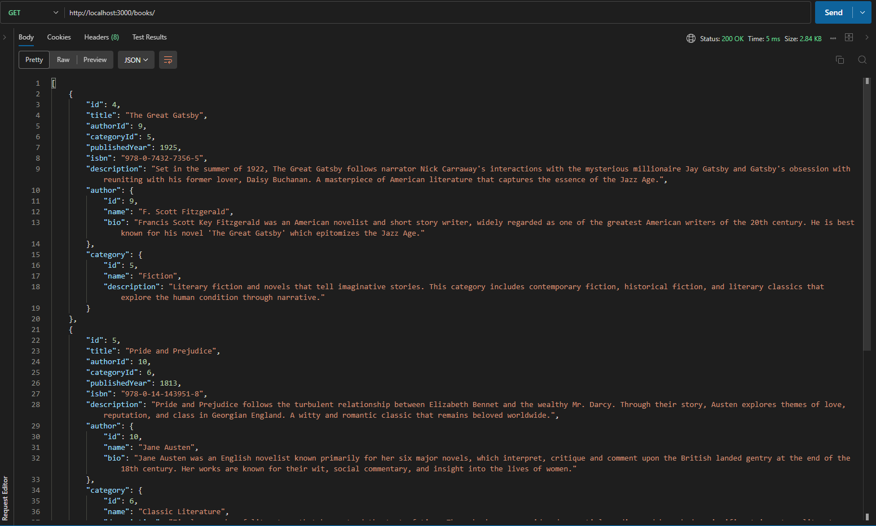
13.GET /books - Get All Books

14. GET /books/4 - Get single books
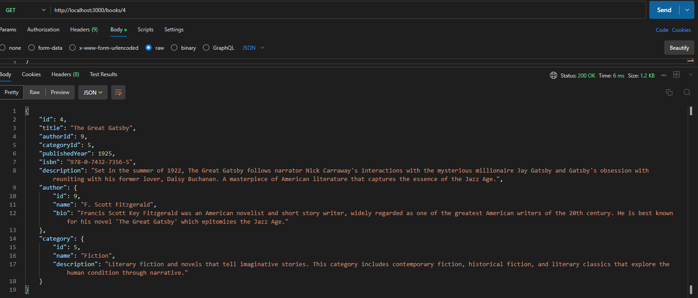

15. UPDATE /books description
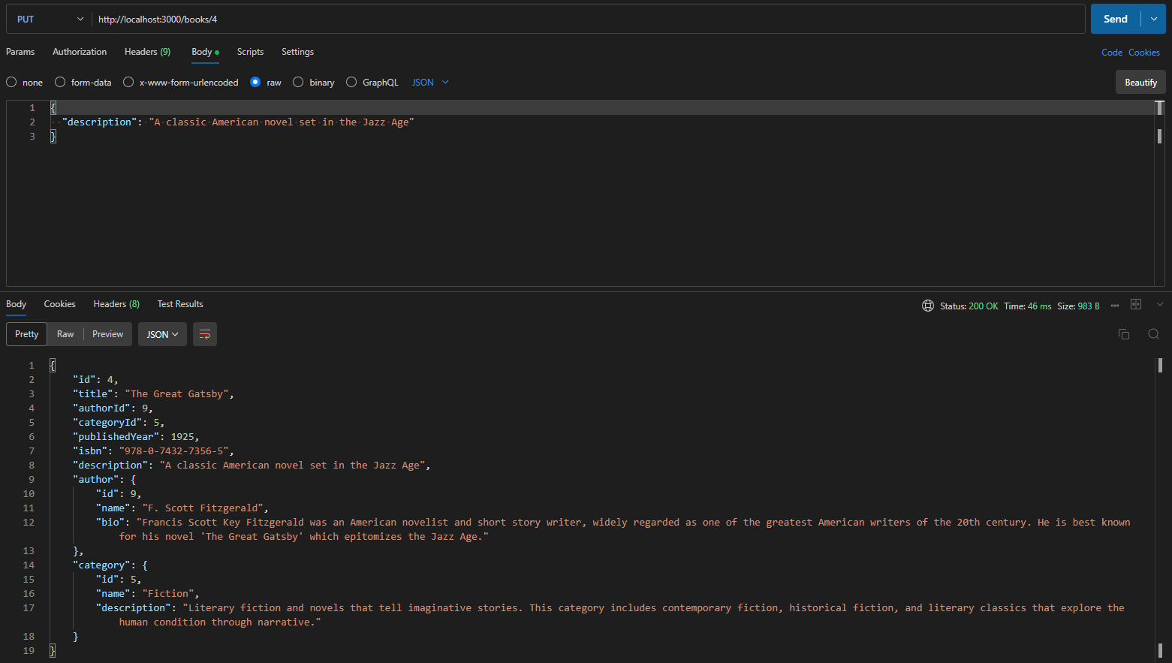

16.DELETE /books/:id
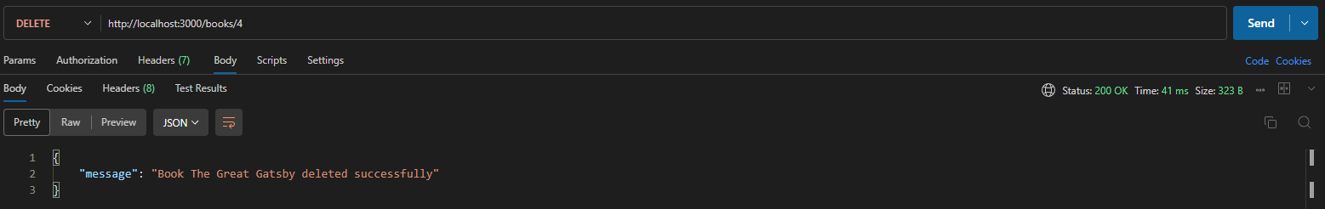

How to Run the Project
Step 1: Backend Setup
1. Navigate to the backend directory:
cd bookshelf-backend
2. Install dependencies
npm install
This will install all required packages including:
- NestJS framework
- TypeORM and SQLite
- Validation libraries
3. Start the backend server:
npm run start:dev

Expected Output:
Backend is now running at: http://localhost:3000

Step 2: Frontend Setup
1. Open a new terminal window (keep the backend running)
2. Navigate to the frontend directory:
cd bookshelf-frontend
3. Install dependencies:
npm install
4. Start the frontend application:
npm start

Expected Output:
Frontend is now running at: http://localhost:3001

The application will automatically open in your default browser.

